1. Distribution of X: X ~ Binomial(n = 50, p = 0.85)
2. 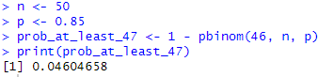
3. Random variable: X = number of calls received in one hour
4. Distribution of X: X ~ Poisson(lambda = 12)
5. A close-up of a number

   AI-generated content may be incorrect.